BUSINESS ENVIROMENT CHAPTER -3
MEANING
The term business environment means the sum total of all individuals, institutions and other forces that are outside the control of a business enterprise but that may effect its performance.
Features of Business Enviroment
- Totality of external forces: Business environment is the sum total of all the forces and factors external to a business firm.
2. Specific and general forces: Business environment includes both specific and general forces. - Specific forces include investors, competitors, customers etc. who influence business firm directly - while general forces include social, political, economic, legal and technological conditions, which affect a business, firm indirectly.
3. Inter-relatedness: Different elements or parts of a business environment are closely interrelated. For example, increased awareness for health care has raised the demand for healthy oil free food and healthy lifestyle.
4. Dynamic: Business environment is dynamic in which it keeps on changing with the change in technology, shift in consumer preferences etc.
5. Uncertainty: Business environment is largely uncertain, as it is difficult to predict the future happenings. Such as, frequent environmental changes in the field of Technology and fashion industry.
6. Complexity: Business environment is complex phenomenon, which is easier to understand in parts, but it is difficult to understand in totality.
7. Relativity: Business environment is a relative concept whose impact differs from country to country, region to region and firm to firm.
IMPORTANCE OF BUSINESS ENVIROMENT
- Business environment enables the firm to Identify opportunities to get the first mover advantage
2. It helps the firm to Identify threats and early warning signal:
3. It helps in tapping useful resources
4. It helps in coping with rapid changes
5. It helps in assisting in planning and policy formulation
6. It helps in improving performance
DIMENSIONS OF BUSINESS ENVIROMENT 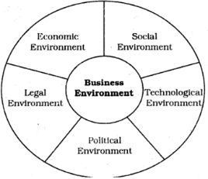
Economic Environment: It has immediate and direct impact on a business. Rate of interest, inflation rate, change in disposable income of people, monetary policy, stockmarket indices etc. are some economic factors, which could affect business firms. - -
- Increase or decrease of the economic factors result in opportunities or constraints on a business enterprise.
Social Environment: Business environment includes various social forces such as customs, beliefs, literacy rate, educational levels, lifestyle, values etc. Social trends present various opportunities and threats to business enterprise.
Example the celebration of Diwali, Eid and Christmas in India provide financial opportunities for confectionery manufacturers, garments businesses and many other related businesses.
Technological Environment: It includes forces relating to scientific improvements and innovations, which provide new ways of producing goods and services and new methods and techniques of operating business. A businessman must closely monitor the technological changes taking place in the industry as it helps in facing competition and improving quality of the product.
Example, Use of artificial intelligence in various companies etc.
Political Environment: It includes political conditions such as general stability and peace in the country and the attitude of the elected government representatives hold towards businesses.
Example: Bangalore is called as the silicon valley of India due to the favorable political conditions provided by the state government to the IT industries
Legal Environment: It includes various laws and legislations passed by the Government, administrative orders, court judgements, decisions of various commissions and agencies at every level of the government center, state or local.
Example: Advertisement of Alcoholic beverages is prohibited.
IMPACT OF GOVERNMENT POLICY CHANGES ONBUSINESS & INDUSTRIES
New Economic Policy 1991 – New economic policy refers to various policy measures and changes undertaken since July 1991.
- To increase the productivity and efficiency of economy by creating the atmosphere of competition.
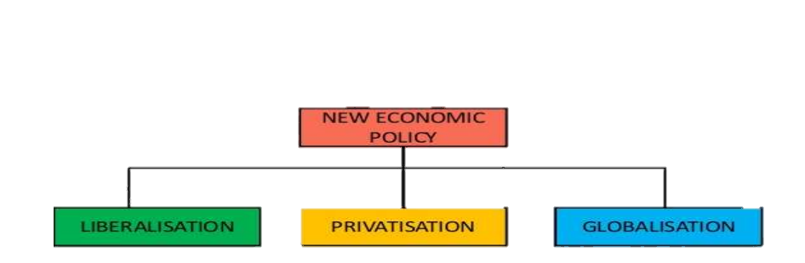

LIBRELISATION
- introduced to liberalizing the Indian business and industry from all unnecessary controls and restrictions.
It relaxed the rules and regulations which restricted the growth of the private sector and also allowed the private sector
to take part in the economic activities

Liberalisation of the Indian industry has taken place with respect to:
a. Abolishing licensing requirement in most of the industries
b. Freedom in deciding the scale of business activities i.e., no restrictions on expansion or contraction of business activities,
c. Removal of restrictions on the movement of goods and services
d. Freedom in fixing the prices of goods services
e. Simplifying procedures for imports and experts, and
f. Making it easier to attract foreign capital and technology to India

PRIVATISATION
The new set of economic reforms aimed at giving greater role to the private sector in the nation building process and a reduced role to the public sector.
The government adopted the policy of divestment and transfer of ownership.
Objectives:
- To introduce plant disinvestment of the public sector.
- Dilute the ownership stake in public sector companies to less than 51%.
- Establishment of the Board of Industrial and Financial Reconstruction to evaluate the loss making and sick enterprises.
- Disinvestment, that means to transfer the ownership from the public sector to the private sector.

GLOBALISATION
globalization means linking the economy of country with the economies of other countries.
to facilitate free flow of goods and services, capital and technology across borders.

A truly global economy implies a boundary less world where there is:
a. Free flow of goods and services across nations;
b. Free flow of capital across nations;
c. Free flow of information and technology;
d. Free movement of people across borders;
e. A common acceptable mechanism for the settlement of disputes;

DEMONITIZATION
The term demonetisation means to invalidate all the currency notes of a particular denomination by the government of a country.
The Indian Government demonetised the two largest denomination notes of Rs 500 and Rs 1000 on 8th November, 2016.
The aim of this move was to curb corruption and illegal activities and stop hoarding of black money.

FEATURES OF DEMONETISATION:
1. Demonetisation is viewed as a tax administration measure. Cash holdings arising from declared income was readily deposited in banks and exchanged for new notes. But those with black money had to declare unaccounted income and pay tax penalty was imposed.
2. Demonetisation is also interpreted as a shift on the part of the government indicating that tax evasion will no longer be tolerated or accepted.
3. Demonetisation also led to tax administration channelizing savings into the formal financial system.

4. Another feature of demonetization is to create a less-cash or cash-lite economy, i.e., channeling more savings through the formal financial system and improving tax compliance.

IMPACT OF DEMONETIZATION
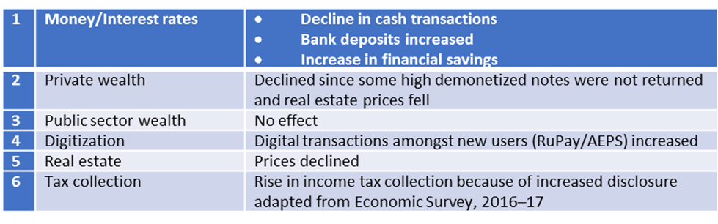
IMPACT OF GOVERNMENT POLICY CHANGES ON BUSINESS AND INDUSTRY

1. Increasing Competition: Changes in the rules of industrial licensing and entry of foreign firm’s Indian market has increased market competition in India.
2. More Demanding Customers: Well-informed customers are more demanding. Increased competition in the market gives customer wider choice of quality products at reasonable price.
3. Rapidly Changing Technological Environment: Increased competition forces the firms to develop new ways to survive and grow in the market.
4. Necessity for Change: After 1991, the market forces have become turbulent, as a result of which the enterprises have to continuously modify their operations.
5. Need for Developing Human Resources: The changing market conditions of today requires people with higher competence and greater commitment, hence there is a need for developing human resources.

