Chapter 2 PRINCIPLES OF MANAGEMENT

PRINCIPLE- - It refers to a statement which reflects the fundamental truth about some phenomenon based on cause and effect relationship.
- a basic general law, rule or idea

Management principles are the statements of fundamental truth which act as guidelines for taking managerial actions and decisions.

Nature of Principles of Management
- Universal applicability:
Principles of management is applicable in all types of organizations, business as well as non-business, small as well as large enterprises depending on the nature of the organisation. Ex. Scalar Chain
2. General Guidelines:
They are general guidelines to solve the problems but do not provide straight solution to all managerial problems, as the business situations are complex and dynamic.
3. Formed by practice and experimentation:
They are formed from the knowledge, experiences and experiments of the managers.
4. Flexible:
These principles are not rigid and can be adapted and modified by the practicing
managers depending upon the situation. Ex. Centralisation & decentralisation
5. Mainly Behavioural:
Since the principles aim at influencing complex human behaviour they are behavioural in nature.
6. Cause and Effect relationship:
They are intend to establish relationship between cause & effect so that they can be used in various situations.
7. Contingent:
Their applicability depends upon the prevailing situation at a particular point of time. The application has to be changed as per the situation.

SIGNIFICANCE OF PRINCIPLES OF MANAGEMENT
- Providing managers with useful insight(tips) in to reality
- Enhances knowledge, ability, understanding various situation
(ii) Optimum utilisation of the resources
(iii) Scientific decisions- based on observation and experimentation
(iv) Meeting changing environment requirements
(v) Fulfilling social responsibility
(vi) Management training, education and research

BACKGROUND & HISTORY OF F.W. TAYLOR
- Scientific Management owes its origin to Fredrick Winslow Taylor.
- Commonly regarded as father of scientific management
- He was born in 1856 in USA
- Started his career as small machine making shop in 1870
- Chief engineer of Midvale steel works in 1884, when he was 28 only.
- He conducted some experiments and researches in management science for more than 2 decades.

MEANING OF SCIENTIFIC MANAGEMENT
- Application of science for each and every element of mgmt.
- Under SM – selection of men, machines, material etc is made by scientific approach
- All organisational activities should be performed by rationality and proper discipline.
- Thus, SM is a logical approach towards the solution of management problems.

PRINCIPLE OF SCIENTIFIC MANAGEMENT
- Science, not rule of thumb
- Taylor has emphasized that each job performed in the organisation should be based on scientific enquiry.
- Not on intuition, experience and hit and miss method.
- Rule of thumb doesn’t involve thinking before doing.
Scientific method requires :
- cause and effect, exact effort required, output to be kept in view for any work to be performed
- Decision are based on facts and thorough work study analysis.
- This method will substitute the rule of thumb.

2. Harmony, not discord
- Taylor believed in co-operation not individualism.
- In group action those work, should carry the task in harmony.
- With mutual give and take and understanding.
Only then it is possible to the group to achieve the goal.
- There should be no conflict b/w managers and works.
- Taylor advocated a complete mental revolution in managers and workers.
- Mangers should adopt an enlightened attitude and share the gains of productivity with the workers.
- Workers on their part should work with discipline and loyalty.
3. Co-operation, not individualism
- It is an extension of the Principle of Harmony not discord,
- there should be complete cooperation between the labour and management
- Taylor suggested that while setting standards, mangers should involve the employees
- Constructive suggestions from employees must be encouraged and desist workers from going on strike and making unreasonable demands.
4. Development of each and every person to his or her
greatest Efficiency and Prosperity:
- taking actions for the development of competencies of all persons of an
organization
- Proper arrangement of training
- Taylor insisted that each and every employee should be given work according to their physical, mental and intellectual capabilities.
- This will increase the productivity by utilizing the skills of the workers fully.

TECHNIQUES OF SCIENTIFIC MANAGEMENT
1. Functional Foremanship
A foreman is managerial figure with whom the workers interacts daily. He is the pivot around whom the production, planning, implementation, control revolves.
.- Functional foreman-ship is a technique in which planning and execution are separate.
• Supervision is divided into several specialized functions and each functions is to be
entrusted to a foreman.
• There are eight foreman in the related process or function of production.
• Four each under planning and execution who keep a watch on all workers performance.
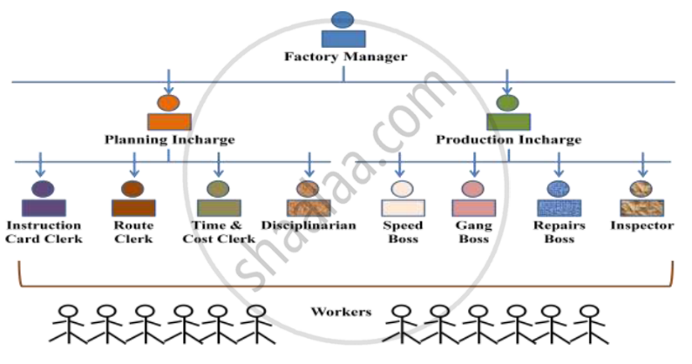
2. Standardization and simplification of work
Standardization refers to developing standards for every business activities to maximize output.
Simplification refers to eliminating unnecessary varieties, sizes and grades of products or services.
- It results in savings of cost of labour, machines and tools.
- It leads to fuller utilization of equipment and increase in turnover.

3. Work Study
a. Fatigue Study
Fatigue study seeks to determine time and frequency of rest intervals in
completing a task.
The rest interval will enable workers to regain their lost stamina thereby
avoiding accidents, rejections and industrial sickness.
(Kitna aapko rest dena hai, kitni der ke bd dena hai, kitni bar dena hai)

b. Method Study
The objective of method study is to find out one best way of doing the job
- To maximize efficiency in the use of resources and to reduce cost of production
c. Time Study
The objective of time study is to determine the standard time taken to perform a
given job or task. The measuring devices are used for each elements of task.
d. Motion Study
It is the science of identifying and eliminating wasteful movements resulting
from unnecessary, incidental and unproductive motions of the workers so that it
takes less time to complete the job efficiently.

4. Differential piece wage system
- Taylor suggested two piece wage system for efficient or inefficient workers
- higher for those who achieve upto and more than standard output i.e. efficient workers
- and lower for inefficient and slow workers.
- Thus, efficient workers will be rewarded & inefficient will be motivated to improve their performance.

BACKGROUND & HISTORY OF HENRY FAYOL
- Father of General Management
- He was born in 1841 in France
- Graduated in 1860 as mining engineer and joined French Mining Company.

14 Principles of Management
DIVISION OF WORK
- Work is divided in small tasks/job
- to a trained specialist who is competent enough to perform that job. (according to his capability, qualification and exp.)
- Thus it leads to greater efficiency, specialization, increased productivity
AUTHORITY & RESPONSIBILITY
- Authority means power to take decisions and
- responsibility means obligation to complete the job
- There should be a balance between authority and responsibility.

DISCIPLINE
- Is the obedience to organizational rules and employment agreement, which are necessary for the working of the organisation.
- Discipline requires good supervisors at all levels, clear and fair agreements and judicious application of penalties.

UNITY OF COMMAND
- According to Fayol there should be one and only one boss for every individual employee.
- It implies that every worker should receive orders from one superior only,
- otherwise it will create confusion, conflict and duplication of work.
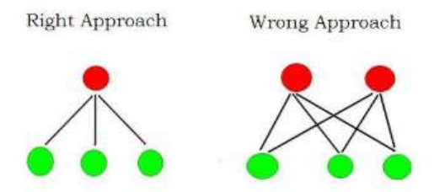
UNITY OF DIRECTION
- All the units of an organisation should move towards the same objectives.
- Each group of activities having the same objective
- Must have one head and one plan. This ensures unity of action and coordination
 | UNITY OF COMMAND | UNITY OF DIRECTION
Meaning | states that one should get orders  from and report to only one boss. | implies that all the  activities with same objective must  have one head and one plan.
Purpose | To prevent dual subordination. | To prevent duplication of activities.
Implications | It effects an individual employee | It effects the entire organization
Outcome | The principle leads to effective  functioning of the subordinates. | The principle results in coordination  of work of various employees and  managers

SUBORDINATION OF INDIVIDUAL INTEREST TO GENRAL INTEREST
- . The interest of an organization should take priority over the interest of any individual employee.

REMUNERATION OF EMPLOYEES
- The overall pay and compensation should be, fair to both
employees and the organization.
- The employees should be given fair wages so that they can have a reasonable standard of living.
- Wages should be within the paying capacity of the organisation

CENTRALISATION AND DECENTRALISATION
- Centralization means concentration of decisions
making authority with some,(Top level)
- Decentralisation distributes the power at every level of mgmt.
- Both should be balanced, as no organization can be completely centralized or completely decentralized.
SCALAR CHAIN
- The formal lines of authority and communication between superiors and subordinates from the highest to the lowest ranks
- This chain should not be violated but in case of emergency employees at same level can contact through Gang Plank by informing their immediate superiors.
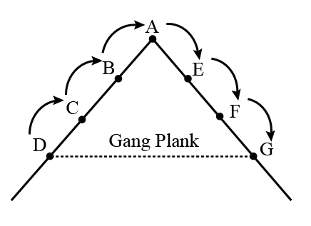
ORDER
- According to Fayol “ People and material should be in suitable places at appropriate time for maximum efficiency”.
- A place for everything and everyone and everything and everyone should be in its designated place

EQUITY
- Good sense and experience are needed to ensure fairness to all employees who should be treated as fairly as possible.
- The working environment of any organization should
- be free from all forms of discriminations
- principles of justice and fair play should be followed.
- No worker should be unduly favoured or punished.

STABILITY OF PERSONNEL
- A personnel should be selected and appointed after proper and procedure
- and the selected person should be kept at the post for a minimum tenure to show results.

INITIATIVE
- Workers should be encouraged to develop and carry out their plan for improvements.
- Initiative means taking the first step with self-motivation.
- Suggestion, reward etc

ESPIRIT DE CORPS
- Management should promote team spirit, unity and harmony among employees.
- ‘I’ should be replaced with ‘WE’ in all the conversation

