`Directing means giving instructions, guiding, counseling, motivating and leading the staff in an organization in doing work to achieve Organizational goals.
Directing is a key managerial function to be performed by the manager along with planning, organizing, staffing and controlling.

Features/ Characteristics
Initiates action: Directing initiates action through instructions supervision and motivation to achieve goals.
All pervasive: Directing takes place in every organization, and at every level of management.
Continuous process: Directing is a continuous process and takes place throughout the life of an organization.
Flows downward: Directing flows downward from superior to subordinate

Importance of Direction
Initiates action: Directing helps to initiate action towards attainment of desired objective.
Integrates efforts: It integrates individual efforts as group effort to achieve organizational objectives.
Provide leadership and motivation; Directing motivates and provides effective leadership to employees to realise their full potential.
Brings changes: Directing introduces changes in the organization through proper communication, motivation and leadership.
Maintain stability: Balance and stability in the organization could be maintained through effective directing.

Principles of Directing
Maximum individual contribution: Through effective directing a manager must help the employee to realise his full potential, and contribute maximum towards the achievement of organizational goals.
Harmony of objectives: Through effective directing, managers must provide harmony between employee’s individual objectives and organizational objectives.
Unity of command: Employees must get instructions and direction from one superior for effective directing.
Appropriateness of direction technique: A manager must choose different direction tools according to the situation for effective direction.

4 Elements of Directing
- Supervision 2. Motivation 3. Leadership 4. Communication
SUPERVISION
• It is a process of guiding the efforts of employees and other resources to accomplish desired objectives.
• Overseeing the work and activities of workers and employees
• Involves instructing, observing, monitoring and guiding employees.
• It is an important function at the lower levels of management therefore the term 'Supervisor’ is used at the operatives level of management

Importance of Supervision
- Supervisor maintains good contact with workers. A good supervisor acts as a
guide, friend and philosopher to the workers.
2. Supervisor acts as a link between workers and management as he/ she explains
management policies to workers and brings workers problems to the notice of the
management.
3. Supervisor plays a key role in maintaining group unity among workers placed under his
control.
4. Supervisor ensures performance of workers is according to the set targets.
5. Supervisor provides good on the- job training to the workers and employees.
6 . A good supervisor analyses the work performed by workers and gives feedback to the
workers.

MOTIVATION
• Motivation means incitement (Utejena) or inducement (prerit) to act or move.
• Motivation is the process of stimulating people to action to accomplish desired goals.
Three key terms = motive, motivation, motivators
Motive : Inner state that energizes, activates and directs behaviour towards
goals. Arises out of unsatisfied needs and causes restlessness.
Motivation : Process of stimulating people to action to accomplish desired goals.
Motivators: Technique used to motivate people. E.g. = bonus, promotion, recognition etc

Features and Characteristics
1. Motivation is a Psychological Phenomenon:
Motivation is an internal feeling, such as urge, drives and desires which means it cannot be forced on employees.
2. Motivation is a Goal Oriented Behaviour:
It induces people to behave in a particular manner so that they can achieve their goals. A motivated person works towards the achievement of desired goals.
3. Motivation can be either positive or Negative:
• Positive motivation means inspiring people to work better and appreciating a work that is well done e.g., pay increase promotion recognition.
• Negative motivation means forcing people to work by threatening or punishing them. e.g., issue of memo, demotion, stopping increments etc.
4. Motivation is complex process:
- complex and difficult because the human factor is involved.
- Individuals differs in their needs it changes time to time.

MOTIVATTION PROCESS
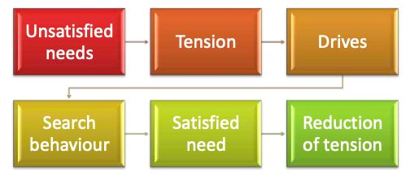
Unsatisfied Want: The motivation process begins with an individual's unsatisfied need.
Tension: As the desire goes unsatisfied, frustration builds up in the individual's mind.
Motives/Drives: Frustration motivates the individual to seek out alternatives to meet his needs.
Search Behaviour: He selects one of several options and begins acting in accordance with it.
Satisfied Needs: After a period of time, he evaluates whether or not his need has been met.
Reduced Tension: Once the need is met, the individual's frustration and tension are relieved.

Importance of Motivation
- Improves performance Level
- Helps to change negative or indifferent attitudes of employees.
- Reduction in Employee turnover.
- Helps to reduce absenteeism in the organisation.
- Reduction in Resistance to change.

MASLOWS’S NEED HIERARCHY THEORY OF MOTIVATION
- This theory was given by Abraham Maslow in 1943, and is based on human needs.
- According to him a man has a countless needs and they can be categorised on the basis of priority.
- A manger must understand the needs and wants of people to motivate and improve their performance level.
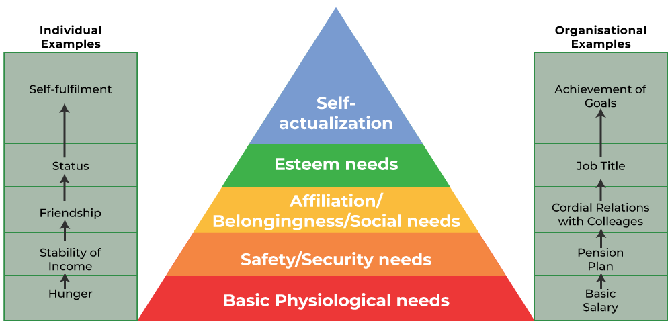
1. Basic Physiological Needs: These are the most basic need such as food, shelter, sleep etc. In the organisational context, basic salary helps to satisfy these needs.
2. Safety/ Security Need: Provide security from physical and emotional harm E.g. Job security,
stability Etc.
3. Affiliation/ Belonging Need: These needs refer to affection, sense of belongingness, acceptance and Friendship for mental satisfaction.
4. Esteem Needs: These include factors such as self-respect, prestige, autonomy status, recognition and attention.
5. Self Actualisation Needs: It is the highest level of need in the hierarchy. It refers to the drive to become what one is capable of becoming. This include growth, self-fulfilment, achievement.

Assumptions
- Satisfaction of needs influences people's behaviour.
- Needs are in hierarchical order.
- Once need is satisfied only, the next higher need can motivate individuals.
- Satisfaction of lower-level needs motivates to move to the next level of need.

Incentive means all measures which are used to motivate people to improve their performance.
I. Financial incentives: refer to incentives which are measurable in monetary terms and serve to motivate people for better performance.
Types of Financial incentives:
1. Pay and allowances: For every employee/ worker, salary is the basic monetary incentive.
2. Productivity linked wage incentives: In this the payment of wages is determined on the basis of the goods produced. This is used for increasing productivity
3. Bonus: Bonus is an incentive offered over and above the wages/ salary for the services
provided by the employees.
4. Profit Sharing: Profit sharing is meant to provide a share to employees in the profits of
the organisation in order to motivate them.
5. Co-partnership/ Stock option: Under these incentive schemes, employees of the
company are given an option to buy the company shares at a set price which is lower than
market price.
6. Retirement Benefits: Retirement benefits are the benefits received either at the time of
retirement or afterwards, such as provident fund, pension, and gratuity. These provide
financial security to employees after their retirement.
7. Perquisites: In many companies perquisites and fringe benefits are offered such as car
allowance, housing, medical aid, and education to the children etc., over and above the
salary.

2. Non-Financial Incentives
- reward that doesn’t from part of salary/wage of the employee.
- It provides psychological satisfaction to an employee.
1. Status: In the organizational context, status means ranking of positions in an organisation, in other words status given to a person holding a managerial position.
2. Organisational Climate: Organisational climate indicates the characteristics which describe an organisation and distinguish it from an another one.
3. Career Advancement Opportunity: A company must provide employees appropriate skill development programmes, and a sound promotion policy to achieve promotions.
4. Job enrichment: It refers to a variety of work offered to challenge the knowledge and skills of highly motivated employees.
5. Employee recognition programmes: It involves recognising and appreciating the contribution of employees in public.
6. Job security: It refers to the certainty and stability offered in a job about future income and work.
7. Employee participation: Involvement of employees in the decision making process, seeking their advice or suggestions.
8. Employee empowerment: Opportunities provided to employees to take decisions independently and perform jobs assigned to them.

LEADERSHIP
Leadership is the process of influencing the behaviour of people in such a way that they voluntarily work towards the achievement of organizational objectives.

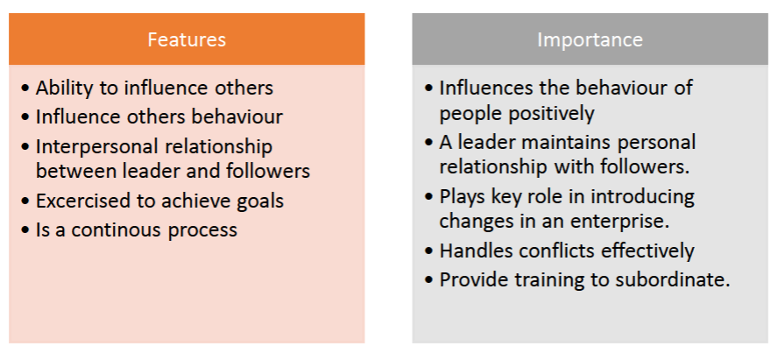
Qualities of a Good Leader
1. Physical features: Should be fit and presentable with positive energy.
2. Knowledge: Should have required knowledge and competence.
3. Integrity: Must possess a high level of integrity and honesty.
4. Initiative: Should grab opportunity and use it to the advantage of organization.
5. Communication skills: Must possess skill to communicate and convince people effectively.
6. Motivation skills: Should motivate the individuals to improve their performance.
7. Self confidence: Should have a high level of confidence to handle difficult situations.
8. Decisiveness: Should be decisive and remain firm on decisions.
9. Social skills: Should be social and friendly with his colleagues and subordinates.

Types of Leadership
- Autocratic or authoritarian Leader
- gives orders and expects others to obey them
- The decision making power is centralised.
Suitability: in the situations where there is little time for decision.
- where the leader is the most knowledgeable member.
2. Democratic and participative leader
- gives order and takes decisions after consulting the group
Suitability: where members are skilled and competent to share their knowledge.
3. Laissez Faire or Free Rein Leader
- leader gives his sub ordinates complete freedom to make decision
Suitability: Full faith in subordinates

COMMUNICATION
It is the process of exchange of information between two or more people with an aim to create common understanding.
Communication is understood as a process of exchange of ideas, views, facts, feelings etc. It is transfer of information from the sender to the receiver.
Elements of Communication Process
1. Sender: the person who conveys his thoughts or ideas to receiver.
2. Message: Ideas, feelings, suggestions, order etc. intended to be communicated.
3. Encoding: the process of converting the message into communication symbols such as
words/pictures etc.
4. Media: Path or channel through which encoded message is transmitted to receiver.
5. Decoding: Converting encoded symbols of the sender.
6. Receiver: Who receives the communication of the sender.
7. Feedback: All the actions of receiver indicating that he has received and understood the
message of the sender.
8. Noise: Some obstruction or hindrance to communication like poor telephone connection,
inattentive receiver.

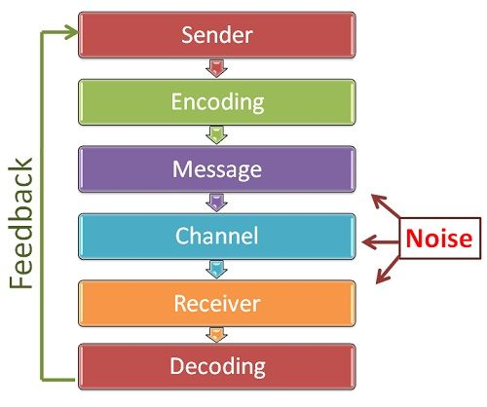
Importance of Communication
-Basis of coordination: Acts as a basis to coordinate their efforts of employees by explaining organizational goals.
-Smooth working of an enterprise: It makes interaction among all individuals possible helping smooth and unrestricted working of an enterprise.
-Basis of decision making: Communication acts as a medium for providing information needed for decision making.
-Increases managerial efficiency:
-Cooperation and industrial peace: The two way communication promotes cooperation and mutual understanding between the management and workers.
-Effective leadership: Effective communication enables a manager to lead and influence his or her subordinate.
-Boosts morale and provides motivation.

Formal Communication
Formal communication flows through official channels designed in the organisation chart.
-There is a two-way information flow between the superior and subordinates. The communications may be oral or written
- The pattern through which communication flows within the organisation is called as
communication network.

Types of Formal Communication
- Single chain: in this communication exists between a supervisor and his subordinates.
2. Wheel: In wheel network, all subordinates under one superior communicate through him only as he acts as a hub of the wheel.
3. Circular: The communication moves in a circle.
4. Free flow: Free flow of communication with each and every one in an organisation.
5. Inverted V: A subordinate is allowed to communicate with his immediate superior as well as his superiors superior.

Informal Communication
Communication that takes place without following the formal lines of communication is said to be informal communication.
Informal communication is sometimes called the grapevine as it spreads throughout the organisation
Types of Informal Communication
- Single strand network: each person communicates to the other in a sequence.
- Gossip network : each person communicates with others on a nonselective basis.
- Probability network: the individual communicates randomly with others.
- Cluster network: A person communicates with only those people whom he trusts.
BARRIERS TO COMMUNICATION
I. Semantic Barriers: Concerned with comunication problems and obstructions in the process of encoding or decoding of message into words or impressions. Semantic barriers are as follows:
1. Badly expressed message: Sometimes intended meaning may not be conveyed by the usage
of inadequate vocabulary, wrong meaning words etc.
2. Symbols with different meaning: Words with different meanings confuses the receiver.
3. Faulty translations: The meaning of a message in one language if translated will be different
in other language.
4. Unclarified assumption: Different assumptions may have different interpretations, which
result in confusion.
5. Technical Jargon: Usage of technical words by specialists will result in misunderstanding
among workers.
6. Body language and gesture decoding: Every movement of body communicates a meaning

II. Psychological/Emotional barriers: Emotional or psychological factors acts as barriers to communicators.
Some of the psychological barriers are:
1. Premature evaluation: judgement before listening leads to misunderstanding.
2. Lack of attention: poor listening due to preoccupied mind of the receiver may disappoint thesender.
3. Loss by transmission and poor retention: When oral communication passes through various channels of communication, it destroys the structure of the message or leads to transmission ofinaccurate message.
4. Distrust: If the parties do not believe each other, they cannot understand each other’s message in its original sense.

III. Organizational Barriers: If the organisation policy is not supportive of free flow of communication it disrupts effectiveness of communication.
1. Organizational policy
2. Rules & Regulations
3. Status
4. Complexity in the organisation structure
5. Organisational facilities

IV. Personal Barriers: Personal factors of both superior and subordinate may influence an effective communication.
Some of the personal barriers of superiors and subordinates are given below:
1. Fear of challenge to authority
2. Lack of confidence of superior on his subordinate
3. Unwillingness to communicate
4. lack of proper incentives

IMPROVING COMMIUNICATION EFFECTIVENESS
Some efforts to improve communication and to overcome barriers are given below
1. Clarify the ideas before communication.
2. Communicate according to the needs of receiver.
3. Consult others before communicating.
4. Be aware of language, tone and content of message.
5. Convey things of help and value to listeners:
6. Ensure proper feedback
7. Communicate for present as well as future
8. Follow up communication: helps to remove hurdles, misunderstanding of
instructions given by managers to subordination.
9. Be a good listener.

