ORGANISNG CHAPTER 5
Organising is the process of
- identifying and grouping the work to be performed,
- defining and delegating responsibility and authority,
- and establishing relationships for the purpose of enabling people to
- work most effectively together in accomplishing objectives.
Organising Process
- Identification and division of work.
- Departmentalisation. (Production, Sales, Marketing, HR)
- Assignment of duties.
- Establishing reporting relationship.
- Identification and division of work.
1.Identification and division of work.- The first step in the process of organizing involves identifying and dividing the work in accordance with the predetermined plans.
The work is divided into manageable activities so that duplication of work can be avoided and the burden of work can be shared among the employees.
2. Departmentalisation- • Once work is divided into small activities, similar and related jobs are grouped together.
This grouping is called departmentalization.
• E.g. departmentalization on the basis of territory, products etc.
3. Assignment of Duties - • Once departments are formed, individual department heads are appointed for each departments.
• The work must be assigned to those who are best fitted to perform it well.
• E.g. finance job should be assigned to persons having qualifications and experience in finance e.g. C.A‘s or MBA finance.
• It is important to state clearly the work of different job positions and allocate work accordingly to employees.
4. Establishing Reporting Relationship - • Establishing authority and responsibility relationship
• It helps to create a hierarchal structure and also helps in coordination amongst various departments.
• Superior subordinate relations between different people and job positions is to be created, so that everybody knows from whom he/she is to taking orders and to whom he/she can issue orders.
Importance of Organising –
1. Benefits of specialization: - The division of work into smaller jobs reduces workload and enhance productivity and repetitive performance leads to specialization.
2. Clarity in working relationships: Organising helps in defining all the jobs and also clarifying the limits of authority and responsibility of each job.
- It helps in creating a hierarchical order
3. Optimum utilization of resources: Organisation leads to usage of all natural resources, financial resources and human resources.
• The proper assignment of jobs avoids duplication of work and minimizes wastage of resources.
4. Effective Administration: It provides a clear description of jobs and related duties, which helps to avoid confusion and duplication of work.
Clarity in working relationships enables proper execution of work, which results in effective administration.
5. Adaption to Change: The process of organising is flexible which allows a business enterprise to accommodate changes in the business environment.
6. Development of Personnel: A well designed organization structure encourages initiative and relative thinking on part of the employees.
- When managers delegate their authority, it reduces their workload and thus can give opportunity to innovate thereby.
7. Expansion and growth: Organising helps in growth & diversification of an enterprise.
- By adding more job positions, departments, products lines, new geographical territories etc. and thus will help to increase customer base, sales and profit.

ORGANISATIONAL STRUCTURE
Defined as framework within which managerial and operating task are performed.
(Network of job position, responsibility and authority on various levels)
SPAN OF MANAGEMENT – It refers to the number of subordinates that can be effectively managed by a manager superior.
Narrow span of mgmt. = Tall structure
Wide span of mgmt. = flat structure

TYPES OF ORGANISATIONAL STRUCTURE
- Functional Structure –
In functional structure activities are grouped or departments are created on the basis of functions.
- Based on functions. Financial, Production, Sales, Marketing
- Groups similar or related jobs together on the basis of functions.
MERITS
- Functional Specialisation
- Better control
- Managerial and operational efficiency.
- Economical
- Ease in training employees.
- Due Attention
DEMERITS
- Functional Empires
- Problems in coordination
- Conflicts of interest
- Inflexibility
- Difficult to fix accountability

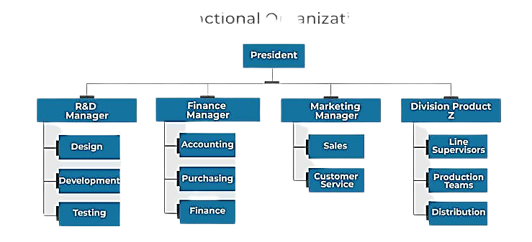

SUITABILITY
• Organizations which require high degree of functional specialization with diversified activities.
• Large organizations producing one line of product.

2. DIVISIONAL STRUCTURE
- Based on Products.
- Groups similar or related jobs together on the basis of products.
MERITS
- Product Specialisation
- Greater Accountability
- Flexibility and initiative
- Expansion and growth
DEMERITS
- Conflicts
- Costly process
- Ignoring of organisational interest
- More resources required

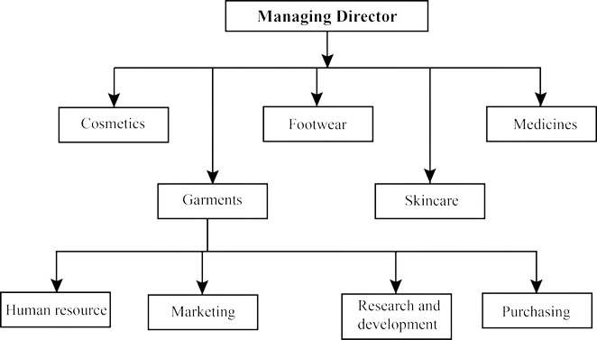

SUITABILITY
•This structure is suitable in organizations producing multi product or different lines of products requiring product specialization. •Growing companies which intend to add more lines of products in future adopt this structure.

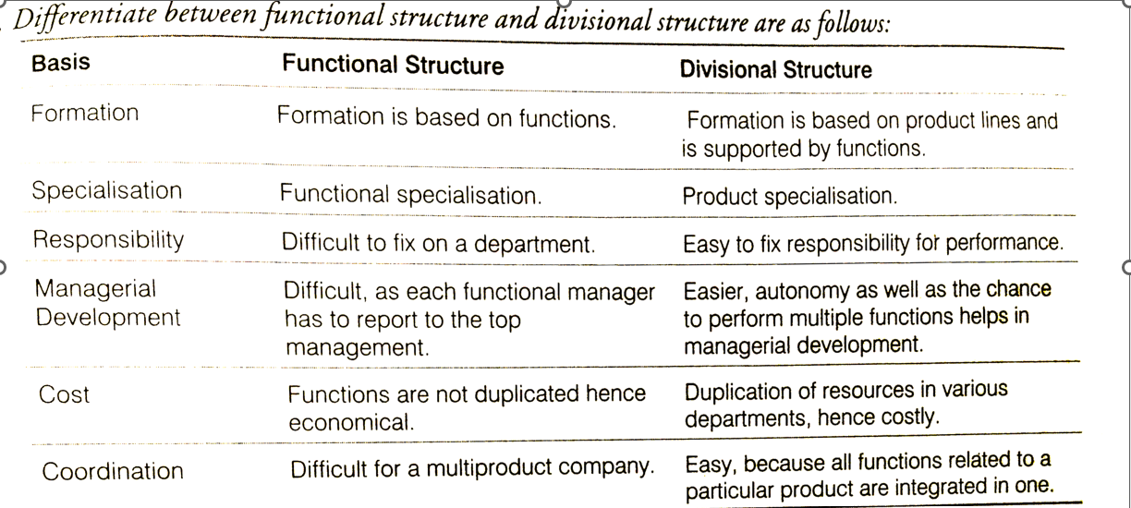

TYPES OF ORGAINSATIONS
- Formal organisation refers to the organisation structure that is designed by the management to accomplish organizational goals.
- Creates a scalar-chain of communication.
- Each individual is assigned a specific job.
- Created intentionally by the process of organising.
CHARACTERISTICS
- Forms superior- subordinates relationship
- Unity of command is followed
- Purpose is achievement of organisational goal.
- Relations among members are fully professional
- Delegation of authority flows from top to bottom
ADVANTAGES
- Systematic working
- No overlapping
- Co-ordination
- More emphasis on work (No interpersonal relationship)
- Responsibility is fixed
- Provides stability
DISADVANTAGES-
- Delay in action.
- Ignore social needs
- Focus on work only
2. INFORMAL ORGANISATION
- Gets created automatically without any intention.
- Formed by employee to get psychological satisfaction.
- Doesn’t follow any fixed path of communication.
- Existence of informal organizational – depends on formal

CHARACTERISTICS
- It is indefinite and has no structure.
- Network of social and personal relationship
- It has own rules and regulations
- Provides social satisfaction
- It is based on personal attitudes, emotions, likes and dislikes.

ADVANTAGES-
- Fast communication
- Fulfils social needs
- Correct feedback
DISADVANTAGES
- Spreading of rumours
- No systematic working
- More emphasis on individual interest

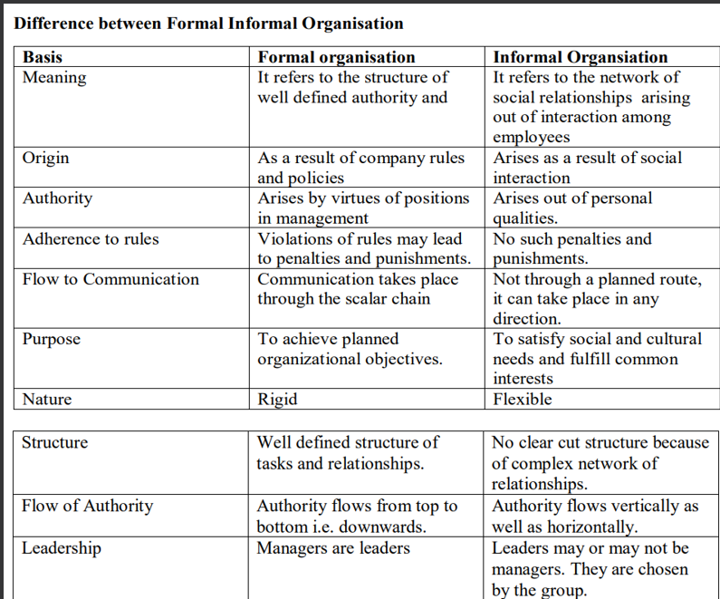

DELEGATION
“Delegation of authority merely means the granting of authority to subordinates to operate within prescribed limits.” - Theo Haimman
Delegation refers to the downward transfer of authority from a superior to a subordinate employees.

Importance of Delegation
- Effective Management
- Employees Development
- Motivation of employees
- Facilitation of growth
- Basis of management hierarchy
- Better coordinatio
ELEMENTS OF DELEGATION
- Authority: Authority refers to the right to take decisions.
- Authority determines the superior subordinate relationship.
- Authority flows downward.
2. Responsibility: Responsibility is the obligation of a subordinate to perform properly the assigned duty. (obligation to perform job)
3. Accountability: Accountability implies being accountable for the final outcome. When a superior assigns a work to a subordinate, he/she is answerable to the superior for its outcome.
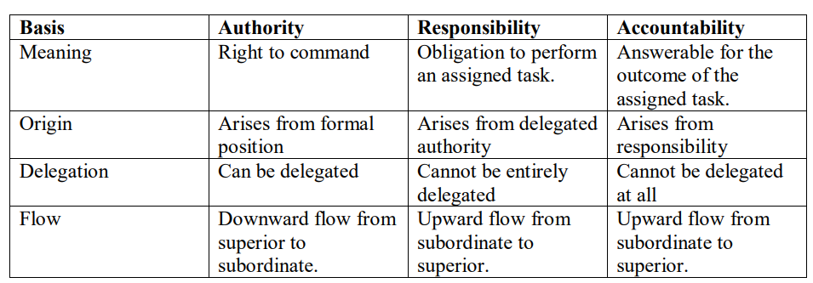
DECENTRALISATION
- Systematic dispersal of authority to lowest level.
- Except that which can be exercised at central points.
“Decentralisation refers to systematic efforts to delegate to the lowest level, all authority except the one which can be exercised at central points”. - Louis Allen

- Develops initiative among subordinates: It helps to promote confidence and self reliance in the subordinates as they are given freedom to take their own decisions.
- Develops managerial talent for future: Training given by the organisation and the experience gained from handling the projects increases the talent of the managers and employees.
- Quick decision making: Since the managerial decisions are taken at all levels nearest to the point of action helps them to take better and quick decisions.
- Relieves the top management: By the delegation of work, the daily managerial jobs are assigned to the subordinates, which leaves enough time with the superiors to look into priority areas.
- Facilitates growth: It allows the departmental heads and employees to perform in the best possible manner considering all the aspects of their department, which in turn increases productivity, efficiency and facilitates growth.
- Better Control: Evaluation of performance is possible at each level, which results in complete control over all the other activities.
