MARKETING
MEANING OF SOME IMPORTANT TERMS:
• Needs = basic human requirements. Essential items necessary or fundamental to human existence.
Need is a State of feeling deprived of something and it does not pertain to a particular product
• Wants= desire for a particular product. Tend to be “satisfier specific”.
Want -Human needs shaped by some factors such as culture, personality and religions
• Demand- willingness to buy is backed by purchasing power
• Utility – want satisfying power of a product.

MEANING OF MARKET
The term ‘market’ refers to the place where buyers and sellers gather to enter into transactions involving the exchange of goods and services.
The term ‘Market’ has been derived from the Latin word ‘Marcatus’ which means ‘to trade’.
- Market refers to a place where transactions take place between buyers and sellers with respect to exchange of goods and services.
- process of interaction between buyers and sellers with the objective of exchange of goods and services.
- Marketing is defined as "a human activity aimed at satisfying needs and desires through an exchange process."
Philip Kotler -
Marketing concept is a key to determining the needs, desires of target markets, delivering the desired satisfactions more efficiently and effectively by competitors is critical to achieving organizational goals.
Functions which are performed under marketing - planning, designing the product, packaging and labelling of the product, standardising, branding, warehousing, transport, advertising, pricing and distribution.

Features of Marketing
1. Needs and Wants:
• helps consumers in obtaining what they need and want.
• A need is a state of deprivation or a feeling of being deprived of something.
2. Creating a Market Offering:
Market offering refers to a process of offering and introducing a product or service, having given features like size, quality, taste, etc. for the purpose of selling.
3. Customer Value:
- Marketing leads to exchange of products and services between buyers and sellers.\
- For customers to buy a product: Value of the product > Cost/price of the product
- Marketer should add to the value of the product so that customers
prefer it over competitors.
4. Exchange Mechanism:
• The process of marketing works through the exchange mechanism.
• Exchange refers to the process through which two or more parties come together to obtain the desired product or service from someone, offering the same by giving something in return. For E.g. money is the mode of exchange used to buy/ sell a product
or a service.
• Conditions to be satisfied for exchange:
a. At least two parties
b. offering something of value to the other
c. communication
d. Freedom to accept or reject offer
e. Parties willingness to enter into a transaction

What can be marketed?
· Products (e.g. bottle, soap, TV, refrigerator)
· Services (e.g. banking, transport, insurance)
· Experiences (e.g. stage shows, plays, movies)
· Persons (eg. Actors,)
· Places for tourists (e.g. Agra, Singapore)
· Ideas (e.g. no smoking, blood donation)
· Information such as technology information or market information
· Tangible and intangible properties such as real estate (tangible) and shares (intangible)

Marketer
A marketer is anyone who makes an extra effort to identify the needs of the consumers and offer the product or service as well as persuade them in order to buy in the process of exchange.
Seller
Sellers, as marketers, are the ones who provide satisfaction. They make products/services available and sell them to customers in order to meet their needs and desires.
They are classified as follows:
a. goods marketers (such as Hindustan Lever)
b. services marketers (such as Indian Airlines)
c. others marketing experiences or places (such as Walt Disney) (like tourist destinations).
Marketing activities are those undertaken by marketers in order to facilitate the exchange of goods and services between producers and consumers.

MARKETING MANAGEMENT
According to American Management Association, marketing management is defined as
“the process of planning and executing the conception, pricing, promotion and distribution of ideas, goods and services to create exchanges that satisfy individual and organisational goals”.
Activities involved in marketing management comprise planning, organising, directing and controlling.
“Marketing management is defined as the art and science of selecting target markets and acquiring, retaining, and growing customers by creating, delivering, and communicating superior customer service.” - Philip Kotler

PROCESS OF MARKETING MANAGEMENT
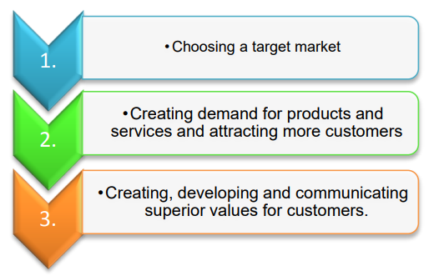
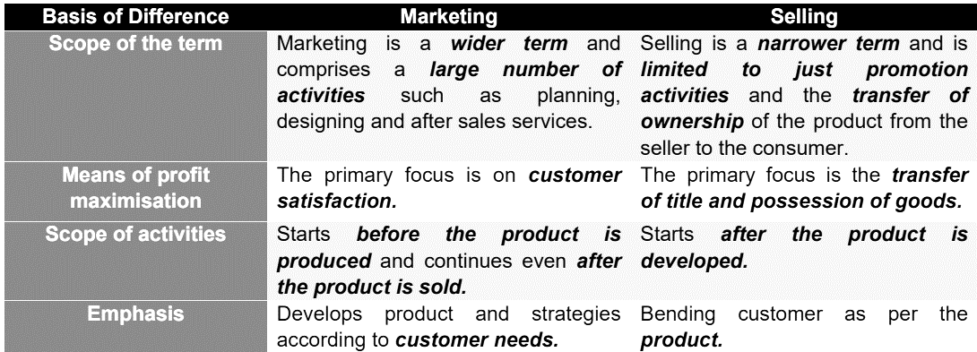

MARKETING MANAGEMENT PHILOSOPHIES
1) Production concept
· During the earlier years of the Industrial Revolution, the demand for industrial goods was
greater than the supply because the producers for these goods were less.
· Selling was not a problem; anybody who can produce can sell.
· Hence, the main focus of business activities turned towards the production of goods.
· Profits can be maximised through large-scale production, thereby reducing the average cost of production.
· Consumers generally favour products which are widely available at affordable prices.
2) Product concept
· Emphasis on production capacity led to increase in supply over a period of time.
· More supply and lower price could not ensure increased sales and further survival and
growth for the firm.
· This increase in supply of products led to a change in consumer outlook and consumers started looking for superior quality products with more features and better performance.
· Emphasis shifted from quantity production to quality production.
· Profits could be maximised through product improvement.
· Hence, the primary focus is good quality and offering additional and new features in
products.
3) Selling concept
· Changes in the marketing environment over a period of time lead to increased competition among sellers.
· Now, the need was felt to attract customers and convince them to buy the product.
· To sell products, firms must use aggressive selling and promotional techniques as it was observed that a customer would not indulge in buying the products unless they were persuaded and motivated to do so.
· Promotional activities like advertising, personal selling, sales promotion etc. prove to be helpful in selling products.
· Thus, the primary focus is to sell produced goods by using intensive promotional techniques.
4) Marketing concept
· This concept lays down that customer satisfaction is the most important factor which determines the success of an organisation.
· The primary focus of business is on customer satisfaction.
The following points explain in brief the marketing concept:
o It should work towards developing products and services which are according to the needs of customers and should satisfy them.
o It must ensure that the product can satisfy the needs of customers better than that done by competitors.
According to the marketing concept, if organisations focus on customer satisfaction, then marketing would take place in an effective and smooth manner. If products are according to the needs of customers, then selling would be an easy task
5) Societal concept
· This concept gives adequate consideration to social problems like environment pollution, deforestation, shortage of resources, overpopulation etc.
· All business activities which satisfy human wants and needs but are detrimental to the interests of society cannot be said to be justified in any way.
· Business should not ignore the interest of society at large but consider the issues of long term social welfare while serving customers.
· Businessmen must identify and meet the needs and wants of the target market and deliver in an effective and efficient manner taking care of the long-term well-being of customers as well as society.
· Primary focus is on customer needs along with society’s well-being.

FUNCTIONS OF MARKETING
1) Analysing and assembling market information
· Analyse the market and identify the best opportunities.
· Collecting information of the target market segment including the size of the market as well as behaviour, culture, needs and wants of customers.
2) Marketing planning
· Creating a market plan to achieve the marketing goals and objectives of the organisation.
3) Product designing and development
· Design of a product like shape and style attracts customers towards the product.
· Good design improves the performance of the product and helps the product to gain a
competitive advantage in the market.
4) Standardisation and grading
· Standardisation: Production of goods with certain specific qualities (such as durability, safety and utility) and achieve uniformity of goods to ensure that the goods meet the expectations of the predefined standards.
· Grading: Classification of the product according to certain important characteristics such as size, quality etc.
5) Packaging and labelling
· Packaging: Developing a cover or a package for the product to protect it from damage.
· Labelling: Developing a label or slip to be put on the package and providing the necessary
information about the product.
· Both these functions are important for the success of a product.
6) Branding
· Producers need to decide whether to sell the products using its generic name (i.e. general name used for an entire category of the product) or a brand name (i.e. name specific to that particular product such as Lexi pens or Lays wafers).
7) Customer support services
· Involves handling complaints and feedback of customers
· Customer support services are developed such as credit, maintenance, technical services,
consumer information etc.
8) Product pricing
· Price refers to the amount of money to be paid by consumers for purchasing the product.
· Price of the product is inversely related to the demand of the product which means lower the price of the product, higher is its demand.
9) Promotion
· Promotion includes informing customers about products and encouraging them to purchase products.
· Various promotional techniques are used such as sales promotion, personal selling, advertising, maintaining public relations etc.
10)Physical distribution
· Channels of distribution are to be decided through which products would be moved from the place of production to the place of consumption.
· It includes activities like managing the inventory, storage and warehousing.
11)Transportation
· Actual movement of goods from the place of production to the place where it will be consumed or used.
· Goods transportation helps in increasing the reach of the product to a large area.
12)Storage and warehousing
· Goods are stored in the warehouses properly till the time they are sold in the market.
· This ensures smooth flow of the supply of goods.

MARKETING MIX

· Marketing mix means the set of various marketing tools used by an organisation to achieve the desired objectives of marketing.
· In an organisation, various decisions with respect to marketing are affected by a large number of factors, some of which are controllable, while the others are non-controllable.
o Controllable factors refer to factors which can be controlled/influenced by the firm; for instance, price, branding and advertising.
o Non-controllable factors refer to factors which cannot be controlled at the level of a firm; for example, government policies, inflation or the policies of commercial banks.

Elements of Marketing Mix
These elements are used to popularly known as 4 P’s of the marketing.
1. Product: A product is defined as "anything of value" that is offered for sale in the market. Colgate, Dove, and so on.
2. Price: the sum of money that a customer must pay in order to obtain a product or service.
3. Place: Physical product distribution, i.e. making the product available to customers at the point of sale.
4. Promotion: Informing customers about the products and convincing them to purchase them.

- PRODUCT – 1st P
In terms of marketing,
- A product refers to the mix of various tangible and intangible attributes of a product
- which have a value and can be exchanged.
- They are capable of satisfying the needs of consumers.
- Besides physical goods, a product includes services.
- After sales services such as customer care, addressing consumer complaints and taking feedback are also part of the product.
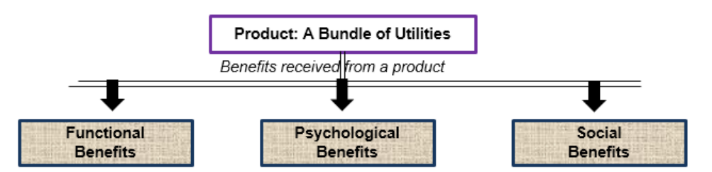

Classification of Product
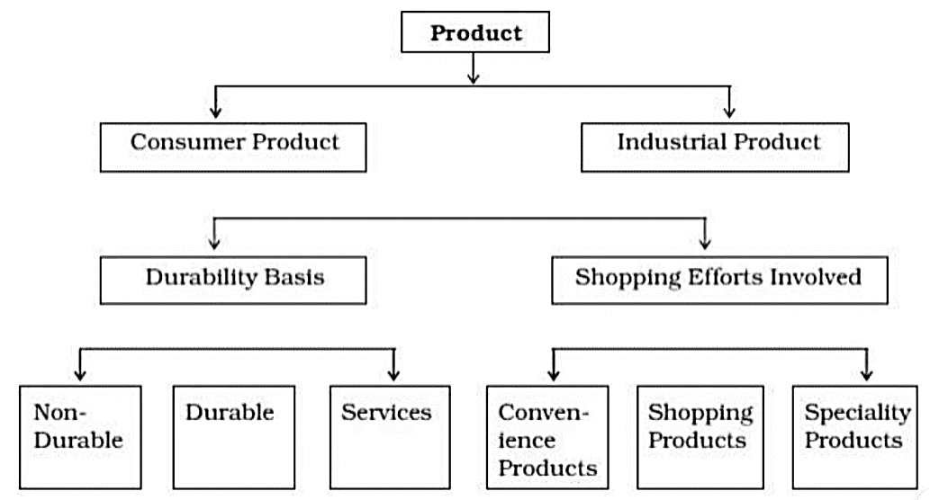
Consumer Products: Products that are bought by individuals or households for personal use.
A. Shopping Efforts Involved -vOn the basis of the buyers' time and effort.
1. Convenience Products: Convenience goods are consumer products that are frequently purchased for immediate use. Medicines, newspapers, stationery, toothpaste, and so on.
2. Shopping Products: Shopping products are those in which buyers spend a significant amount of time comparing the quality, price, style, suitability, and so on at various stores before making a final purchase. For example, electronic goods, automobiles, and so on.
3. Specialty Products: Specialty products are goods that have unique characteristics that compel customers to go out of their way to purchase them. For example, art, antiques, and so on.
B. Durability of Products
1. Non-durable Products: These are consumer goods that are consumed in a short period of time. For example, milk, soap, stationery, and so on.
2. Durable Products: Tangible items that can withstand repeated use, such as a refrigerator, radio, bicycle, and so on.
3. Services: Intangible services are those activities, benefits, or satisfactions that are sold, such as dry cleaning, watch repairs, hair cutting, postal services, doctor services, and so on.

INDUSTRIAL PRODUCTS are those that are used as inputs in the manufacturing process.
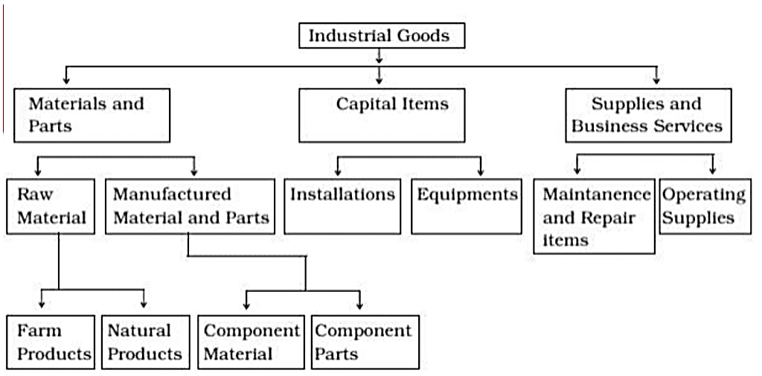
Characteristics
- Number of Buyers - Channel Levels - Geographic Concentration - Derived Demand - Role of Technical Considerations - Reciprocal Buying - Leasing Out

Product Mix
Refers to essential decisions related to product quality, design, packaging and assortment, i.e. number of products or items a particular producer offers to the market.
Components of Product Mix
1) BRANDING
Refers to the process of giving a unique name, sign, symbol or term for the identification of a product. The name can be either a generic name or brand name

Terms related to Brand Name
· Brand Name, term, sign, symbol, design or combination of them used to differentiate the product from competitors’ products. For example, Parker, Raymond etc.
· Brand name Part of brand which can be spoken, i.e. verbal part of brand. For example, Asian Paints, Uncle Chips etc.
· Brand mark Part which can be identified but cannot be spoken. For example, Gattu of Asian Paints or the Devil of Onida.
· Trade mark Part which has legal protection so that no other firm can use such name or mark

CHARACTERISTICS OF GOOD BRAND NAME
a. Simple and short - For example, Pepsi, Coke
b. Self-explanatory - For example, Ujala, Dunkin Donuts etc.
c. Unique ·
d. Adaptable e. Legal Protection
Advantages of Branding to Marketers
· Helps in product differentiation-
· Helps in advertising-
· Differential pricing -
· Easy introduction of new product -

Advantages of Branding to Customers
· Product identification
· Ensures quality
· Status symbol

2. PACKAGING
Packaging is the process of developing, designing and producing a container or wrapper of a product. It is one of the most important functions of marketing.
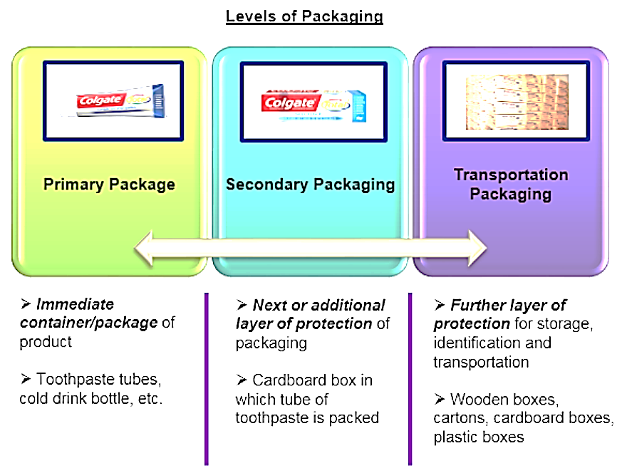
Functions of Packaging
· Protection - Proper packaging protects the product from any kind of damage. For example, chips are packed in air tight containers/packets.
· Identification- Packaging helps to identify the product easily. For example, in a Dove product, the pure white and blue packaging and the letter D can be recognised from a distance.
· Convenience - Packaging enables the consumer to handle the product conveniently. For example, milk packed in packets and cold drinks in bottles are convenient to shift from one place to another.
· Promotion - Packaging helps to promote the sale of the product. For example, the Kinder Joy chocolate’s attractive packaging induces customers to buy the product.

Importance of Packaging
· Rising standard of health and sanitation -Packaged goods are preferred over the loose as the chances of contamination or adulteration of products are less.
· Self-service outlets - Products with attractive packaging are picked by consumers in such stores.
· Product differentiation - Packing enables consumers to differentiate between products on the basis of its size, colour or material of packaging.
· Innovative opportunities - Innovative methods of packaging enable to improve the scope of marketing the products. For example, products now can remain fresh for a longer period of time without refrigeration.
3) LABELLING
Labelling refers to providing information about the product in the form of a tag or a label on the package of the product. Information provided on these tags or labels contains descriptions about a product’s name, date of manufacturing, quality, price, contents, method of use etc.
Functions of labelling
· Description of use and contents -
· Identification - Helps consumers in identifying the product or brand and other useful information as well such as the contents of the product, weight of the product and maximum retail price.
· Grading -Enables grading of the product into various categories. For example, the brand Cadboury sells various flavours of chocolates under different label categories.
· Promotion of the product - A label helps in attracting customers, thereby enabling promotion of the product. Moreover, any information regarding the sales promotion schemes is provided by the label.
· Information required according to law - Information as required by the law is also provided by the label of the product. For instance, it is mandatory for tobacco-producing companies to print a warning message on the packet of the product.

B. PRICE – 2nd P
· Price refers to the amount of money which is paid by a consumer to obtain a
product.
· Generally, the demand for a product shares a negative relation with its price,
which means that as the price increases, the demand for the product decreases
and vice versa.

Factors affecting the price of a product/service
1. Cost of product: Cost of the product is the most important factor determining the price. The cost of product includes producing, selling and distributing costs. It can be classified into the following three types:
o Fixed cost: These are costs which remain fixed irrespective of the level of output. For
example, cost of machinery, land etc.
o Variable cost: These are costs which vary according to the level of output. As the level of
output increases, the variable costs also increase and vice versa. For example, cost of labour and
raw material.
o Semi-variable cost: Similar to variable costs, these are costs which vary with the level of
output but not in direct proportion with it. For example, commission paid to intermediaries.
o Total costs: These costs are the sum total of fixed, variable and semi-variable costs for a specific
level of activity like quantity produced, volume of sales etc.
Generally, a firm decides such a price for its product so that it can cover the various costs and
earn a profit.
2. Utility and Demand:
- The utility provided by the product, as well as the demand for the product, determine the maximum price that a buyer will be willing to pay for that particular product.
- Buyers would be willing to pay until the utility of the demand exceeded or equaled the utility derived from it.
- According to the law of demand, consumers buy more at a lower price.
3. Degree of competition in the market: In case there is high competition in the market, it is not possible for a firm to charge a higher price. This is because if the firm charges a higher price, consumers would shift the demand to its competitors. But if there is less competition in the market, sellers may charge a high price for products.
4. Government regulations: At times, the government regulates the prices of certain commodities.
For example, in the market for agricultural products such as wheat and rice, the government intervenes in price determination.
5. Objectives of pricing: There are various objectives which a firm considers while deciding the price of its product. The following are some important objectives of pricing:
o Profit maximisation:
o Acquiring market share:
o Surviving competition:
o Focus on quality:
6. Marketing Methods Used: Other marketing elements such as distribution system, sales promotion efforts, packaging type, product differentiation, credit facility, and so on all have an impact on the price fixing process.

3. PLACE/PUBLIC DISTRIBUTION- 3rd P
· Place/Physical distribution means the transfer of products from the place of production to the place where they are finally consumed.
· It is concerned with providing goods and services at the right place, in the right quantity and at the right time.
· The firm needs to take decisions regarding:
1. Physical movement of goods
2. Channels or intermediaries which enable the distribution of the product

Channels of Distribution
Channels of distribution are the means through which goods are distributed to final consumers.

Functions of Channel Distribution
1. Sorting: Middlemen obtain supplies of goods from a variety of sources, which are not always of the same quality.
2. Accumulation: the accumulation of goods into larger homogeneous stocks that aid in the maintenance of a continuous flow of supply.
3. Allocation entails dividing homogeneous stock into smaller, more marketable lots.
4. Assorting: the collection of products for resale.
5. Product Promotion: Middlemen take part in activities such as demonstrations, special displays, and so on.
6. Bargaining: Manufacturers, intermediaries, and customers bargain over price, quality, and other issues.
7. Risk Taking: Merchant middlemen take title to the goods, assuming risks such as price and demand fluctuations, spoilage, destruction, and so on.

Types of Channel Distribution
Direct Channel ( Zero Level)
The manufacturer and the customer establish a direct relationship. Manufacturer-Customer. For example, mail order, internet, and door-to-door sales.
Indirect Channel
The distribution network is referred to as indirect when a producer uses one or more intermediaries to move goods from the point of production to the point of sale.
1. Manufacturer-Retailer-Customer (One Level Channel)
Between the manufacturers and the customers, one intermediary, namely retailers, is used. Typically used for high-end items such as watches, appliances, automobiles (Maruti Udyog), and so on.
2. Manufacturer-wholesaler-Retailer-customer (Two Level Channel):
This channel is primarily used for consumer goods distribution. Typically used for consumer goods such as soaps, salt, and so on.
3. Manufacturer → Agent → Wholesaler → Retailer → Customer (Three Level Channel):
Manufacturers use their own selling agents or brokers in this case, who connect them with wholesalers, then retailers, and finally consumers.

Factors determining the choice of Channel Distribution
1. Product Related Factors: The nature of the product, whether it is industrial or consumer goods, perishable or nonperishable, etc., determines the distribution channels used.
2. Company Characteristics: The company's financial strength and the level of control it wishes to exert over other channel members. Short channels are used to exert more control over intermediaries and vice versa.
3. Competitive Factors: Companies may copy the channels used by their competitors. (depends on the channels opted by its competitors.)
4. Market Factors: The size of the market as well as the geographical concentration of potential buyers, volume of demand etc, influence channel selection.
5. Environmental Factors: Legal constraints and a country's economic situation. In a down economy, marketers use shorter distribution channels.

D. PROMOTION – 4th P
· Promotion refers to activities undertaken by the firm with the objective of communicating to potential consumers regarding the availability of a product, its features, special qualities and purpose.
· Promotion of the product is done with the objective of influencing potential customers to purchase the product.

Promotion Mix
A promotion mix is considered as a combination of promotional tools used by a company to achieve its communication goals.
1. Advertising 2. Sales Promotion 3. Public Relation 4. Personal Selling
1. Advertising- It refers to an impersonal technique of promotion of a product which is paid for by the marketers.
- It helps in attracting customers towards the product. Common modes of advertising are newspapers, magazines, television etc.
Features of advertising
· Cost involved: Advertising is a paid form of communication. It involves a cost which is to be borne by sponsors.
· Impersonal mode: Advertising is impersonal in the sense that there is no direct interaction between
the customer and the advertiser.
· Identified sponsors: Advertising is undertaken by identified sponsors who initiate the process and
also provide finance required for it.

Merits
- Mass Reach: a large number of people can be reached across a large geographical area.
- Increasing customer satisfaction and trust.
- Expressiveness: It is a powerful medium of communication.
- Economy: Because of its wide reach, is a very cost-effective mode of communication.
Limitations of advertising as a promotional tool
· Less forceful: An advertisement is an impersonal form of communication and thereby is less
effective.
· Analysis of impact/ feedback deficit: The impact or effectiveness of an advertisement cannot be analysed by the firm.
· Inflexibility: It is a standard form of communication with the potential customer which cannot be altered according to the needs of individual consumers.
· Low effectiveness: There are numerous advertisements for similar products in the market, thereby
its effectiveness is low.

Objections to Advertising
Some critics argue that advertising is a social waste because it raises costs, multiplies people's needs, and undermines social values.
1. Adds to Cost: Unnecessary advertising raises the cost of the product, which is then passed on to the buyer in the form of high prices.
2. Undermines Social Values: Promotes materialism in society by inducing customers to purchase products which sometimes they don’t even need.
3. Confuses the Buyers: A similar product of the same nature/quality confuses the buyer.
4. Encourages Sale of Inferior Products: It makes no distinction between superior and inferior goods. Through extensive advertisements, demand for even inferior goods can be induced.
5. Some Advertisements are in Bad Taste: These depict something that some people do not agree with. Sometimes the language, images and content of an advertisement may not appeal to society at large.

2. Sales Promotion
Refers to the various short-term incentives which are offered to customers so as to influence them to
purchase the product or service.
Sales Promotion Activities
These include activities such as offering discounts, product combinations, offering free samples etc.
· Rebate: Products are offered at a special low price for a specific period of time so that excess inventory can be cleared off.
· Discount: Products are offered at a price which is lower than the market price.
· Refund: It involves giving back some amount of the price paid to the customer on presentation of some proof of purchase.
· Product combination: Offering a product as a gift on the purchase of some other product.
· Quantity gift: Additional quantity of the product is offered at the same price.
· Instant draws and assigned gift: A scratch card or a gift coupon is offered to the customer on purchase of the product
· Lucky draw: Offering products to a selected few as part of a lucky draw.
· Usable benefits: Offering gift vouchers for later use.
· Full finance at 0%: Offering goods in easy instalment schemes.
· Sampling: Free samples of the product in the form of small packets are provided to potential customers at the time of the launch of the product.
· Contests: Events and contests are organised comprising games and activities while promoting the product to attract maximum number of customers.

Merits of Sales Promotion
Attention Value: Using incentives, attract people's attention.
Useful in New Product Launch: Sales promotion tools persuade people to abandon their usual purchasing habits and try new products.
Synergy in Total Promotional Efforts: Sales promotion activities contribute to the overall effectiveness of a company's promotional efforts.
Limitations of Sales Promotion
Reflects Crisis: A company that frequently relies on sales promotion activities may give the impression that it is unable to manage its sales and that its products are unpopular.
Damages Product Image: Customers may believe that the products are of poor quality or are overpriced.

3. Personal Selling
It refers to a personal form of communication with customers in order to make sales.
Features
· Personal form: Involves direct contact between buyers and sellers.
· Development of relationship: Provides the chances of developing a personal relationship
between the buyer and the seller.
Merits of Personal Selling
· Flexibility: Sale presentation of the product can be modified according to the need and preferences
of the customer
· Direct Feedback: Due to direct contact between the seller and buyer, proper and direct feedback can be taken from the buyers and used to adapt the sales presentation according to the needs of the prospective customers.
· Minimum Wastage: Less wastage of efforts as targeted customers are decided by the
firm/company before making contact with them.

Importance to Business Organisation
(i) Effective Promotional Tool
(ii) Versatile Tool
(iii) Reduces Effort Wastage
(iv) Consumer Attention
(v) Long-Term Relationship
(vi) Personal Relationship
(vii) Role in the Introduction Stage
(viii) Customer Relationship
Importance to Customers
(i)Helps in identify Needs
(ii) Up-to-date market information
(iii) Expert advice
(iv) Customers are enticed
Importance to Society
(i)Converts the most recent demand
(ii) Employment Possibilities
(iii) Job Opportunities
(iv) Salesperson Mobility
(v) Standardization of Products

4. Public Relation
It refers to activities undertaken by an organisation to promote or protect the image of the company or its products in the eyes of the public.
Role of Public Relations:
1. Press Relations: A press release is an announcement of an event, performance, or other newsworthy item issued to the press by an organization's public relations professional. It is written in the form of a positive story with an appealing heading in order for the media to quickly grasp and spread the message.
2. Product promotion: The company tries to draw attention to new products by organizing sporting and cultural events such as news conferences, seminars, and exhibitions, among other things.
3. Corporate Communication: The image of the organization is promoted through newsletters, annual reports, brochures, and other means.
4. Lobbying: The organization maintains cordial relations with government officials and ministers in charge of corporate affairs, industry, and finance in regard to business and economic policies.
5. Counselling: The public relations department advises management on general issues affecting the public and the company's position.

