CHAPTER 1
NATURE AND SIGNIFICANCE OF MANAGEMENT

- Management is the process
- of getting things done
- with the aim of achieving goals
- effectively and efficiently.

a. Process: refers to the primary function like planning, organising, staffing, directing and controlling performed by the management to get things done.
b. Effectiveness: means completing the right task to achieve the deputed goal within the time frame.
c. Efficiency: means completion of task in low cost, minimum wastage of resources.

“Management is defined as the process of planning, organizing, actuating and controlling an organization’s operations in order to achieve coordination of the human and material resources essential in the effective and efficient attainment of objectives.” -----Robert L. Trewelly and M. Gene Newport

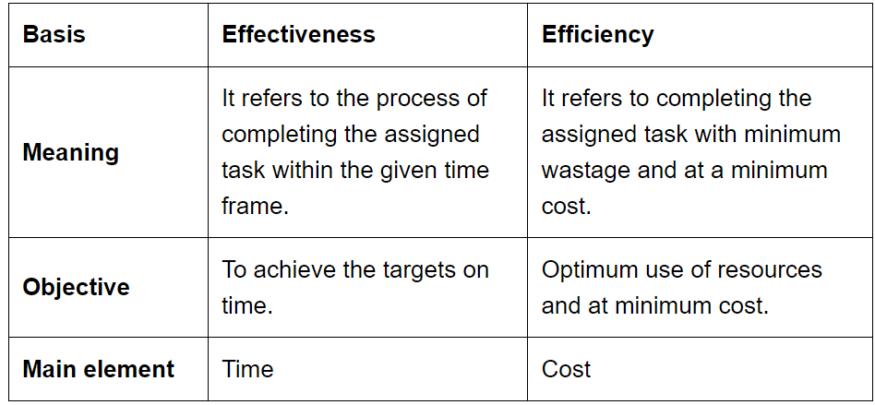

Characteristics of MANAGEMENT
1. Goal oriented process- Management unites the efforts of the individuals towards achieving the one goal.
2. Pervasive- common to all organisations.
3. Multi-dimensional- Three dimensions = Work, People and Operations
4. Continuous process- series of functions performed all the time.
5. Group activity- all individual contributes toward one goal.
6. Dynamic function- adapts itself to its changing environment
7. Intangible force- can’t be seen, but presence can be felt.

Objectives of MANGEMENT
1. Organisational objective –
Survival (Earning enough revenues to cover cost)
Profit (To cover cost and risk)
Growth (To improve its future prospects).

2. Social Objectives –
- provide quality products at reasonable rates
- provide employment opportunities.
- increase standard of living.

3. Personnel objectives-
- Reward to employees
- Healthy atmosphere
- Participation in profit
- social and safety needs of employee.

Importance of MANAGEMENT

1. helps in achieving group goals: Management creates teams and coordinates
with individuals to achieve goals
2. Increases efficiency: using resources - reduce cost and increase productivity.
3. Creates dynamic organization: Management helps change and adapt as per changing situation
4. Achieving personal objectives: Through motivation and leadership management helps the individuals in achieving personal goals while working towards organizational objective.
5. Development of society: by producing good quality products, creating employment opportunities and adopting new technologies

Nature of MANAGEMENT
MANAGEMENT as ART-
- Art refers to skillful and personal application of existing knowledge to achieve desired results.
- It can be acquired through study, observation and experience.

features
1) Existence of theoretical knowledge: In every art, Systematic and organized study material is available to acquire theoretical knowledge.
- In management also, many literature and books are available on different aspects of management.

(2) Personalized application: The use of basic knowledge differs from person to person and thus, art is a very personalized concept.
- Every manager has his own unique style of managing things and people.

(3) Based on practice and creativity: Art involves in consistent and creative
practice of existing theoretical knowledge.
- He uses his creativity in applying management techniques and his skills improve with regular application.

Since all the features of art are present in management. so it can called an art.

MANAGEMENT as SCIENCE
Science is a systematized body of knowledge that is based on general truths which can be tested anywhere, anytime.

features
(1) Systematized body of knowledge: Science has a systematized body of knowledge based on principles and experiments.
- Management has systematic body of knowledge and its principles

(2) Principles based on experiments and observation: Scientific principles are developed through experiments and observation.
- Principles and knowledge of MGMT are developed over a period of time based on repeated experiments & observations

(3) Universal validity: Scientific principles have universal validity and application.
- Principles of mgmt. are universally applicable
As the principles of management are not as exact as the principles of pure science, so it may be called-an inexact science.

MANAGEMENT as PROFESSION
Profession means an occupation for which specialized knowledge and skills are required and entry is restricted.

features:
a. Well-defined body of Knowledge: is complete set of principles, concepts, terms and activities that make up a professional occupation
b. Restricted Entry: The entry in every profession is restricted through examination or through educational degree.
c. Professional Associations: All professions are affiliated to a professional association, which regulates entry and frames code of conduct relating to the profession. Eg. IMA, ICAI
d. Ethical Code of Conduct: All professions are bound by a code of conduct, which guides the behavior of its members.
e. Service Motive: The main aim of a profession is to serve its clients

Management does not fulfill all the features of a profession and thus it is not a full-fledged profession like doctor, lawyer, etc.

LEVELS OF MANAGEMENT
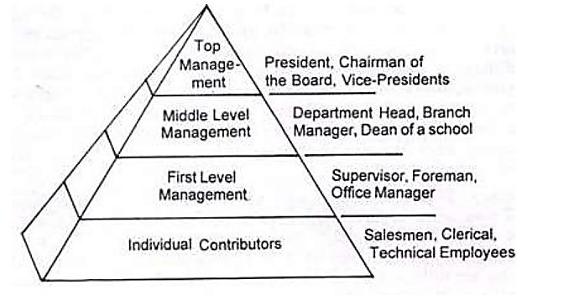

FUNCTIONS OF MANAGEMENT
I. Planning : Setting objectives and targets and formulating an action plan. It bridges the gap between where we are and where we want to reach.
II. Organising: Involves assigning duties, grouping tasks, establishing authority and
responsibility relationships and allocating the resources required to perform a specific plan.
III. Staffing: Finding and placing the right person for the right job at the right time. It involves recruitment, selection, placement, induction and development of employees.
IV. Directing: Refers to leading, influencing, motivating the staff chosen to perform the assigned task efficiently and effectively.
V. Controlling: Refers to monitoring organizational activities towards the attainment of organizational goals. It involves setting standards measuring current performance, comparing with the standards, and taking corrective action for any deviations.

COORDINATION
-Coordination is the force which synchronizes all the functions of management and activities of different departments.
- Lack of coordination results in overlapping, duplication, delays and chaos.
- It is concerned with all the three levels of management.
- Coordination is implicit and inherent in all functions of an organisation.

